Homework 3 (Vivado HLS) Report

# Introduction

This report presents an overview on the design optimization of 8 loop kernels as a part of the Advanced Computer Architecture course (CS-470) at EPFL. It highlights the analysis of each kernel’s naïve implementation followed by the optimized implementation. The explanations and comparative results (in terms of area and timing) for all the optimizations are also presented. Please note that the results are given in terms of clock cycles assuming a clock period of 10ns.

# Kernel-1

The code for the loop kernel is shown below. The same code was used for the optimized version too.

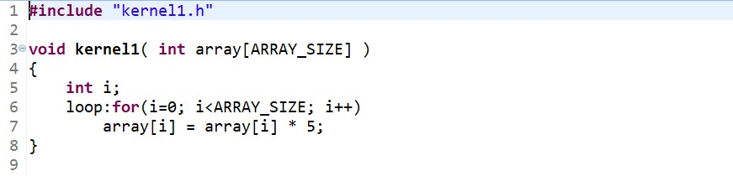

## Optimization Steps

The naïve implementation does not give very good results (see table). The following observations and changes led to an optimized design:

1. The loop can be pipelined using the pipeline directive.
2. Each iteration is independent since it uses a different index i.
3. Hence, it was possible to achieve an initiation interval of 1.

## Synthesis Comparison

The synthesis reports for both the implementations can be compared in terms of timing and area:

**Performance Estimates:** The optimized version has the same trip count and iteration latency since the code was unchanged. However, the loop latency is 2 times better because of pipelining, which led to an improvement in the total latency from 2049 to 1026 cycles.

|  |  |  |  |  |  |  |  |
| --- | --- | --- | --- | --- | --- | --- | --- |
| **Implementation** | **Total Latency** | | **Loop Latency** | | **Iteration Latency** | **Trip Count** | **Initiation Interval** |
| **Min** | **Max** | **Min** | **Max** |
| **Naïve** | 2049 | 2049 | 2048 | 2048 | 2 | 1024 | - |
| **Optimized** | 1026 | 1026 | 1024 | 1024 | 2 | 1024 | 1 |

**Utilization Estimates:** The optimized version uses 12 (10%) more LUTs but 8 (23%) less FFs compared to the naïve version.

|  |  |  |  |  |  |  |  |  |  |  |
| --- | --- | --- | --- | --- | --- | --- | --- | --- | --- | --- |
| **Implementation** | **BRAM_18K** | | **DSP48E** | | **FF** | | **LUT** | | **URAM** | |
| **Unit** | **%** | **Unit** | **%** | **Unit** | **%** | **Unit** | **%** | **Unit** | **%** |
| **Naïve** | 0 | 0 | 0 | 0 | 35 | ~0 | 115 | ~0 | 0 | 0 |
| **Optimized** | 0 | 0 | 0 | 0 | 27 | ~0 | 127 | ~0 | 0 | 0 |

# Kernel-2

The code for the loop kernel is shown below. The code was rewritten for the optimized version.

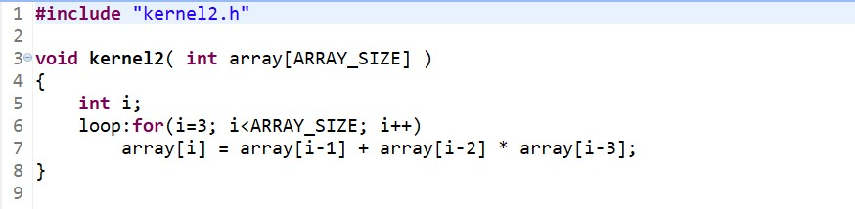

The optimized version of the code is shown below.

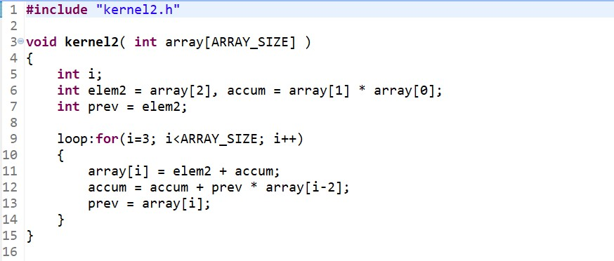

## Optimization Steps

The naïve implementation does not give very good results (see table). The following observations and changes led to an optimized design:

1. The loop can be pipelined using the pipeline directive. But this is not sufficient.
2. The code was rewritten to reduce the number of memory-reads per iteration. The operation within the loop can be seen as: *array[i] = array[2] + accumulation of previous multiplications.*
3. The code was further improved by using a new variable *prev* to store the resulting *array[i]* so that it can be reused in the next iteration. This reduces the need to read *array[i-1]*.
4. Finally, since the resulting code requires to read *array[i-2]* and write *array[i]* every iteration, the inter-iteration dependency on *array* can be disabled using the dependence primitive.
5. Hence, it was possible to achieve an initiation interval of 1.

## Synthesis Comparison

The synthesis reports for both the implementations can be compared in terms of timing and area:

**Performance Estimates:** The optimized version has the same trip count but a better iteration latency after rewriting the code. The loop latency is 5 times better because of pipelining, which led to an improvement in the total latency from 5106 to 1027 cycles.

|  |  |  |  |  |  |  |  |
| --- | --- | --- | --- | --- | --- | --- | --- |
| **Implementation** | **Total Latency** | | **Loop Latency** | | **Iteration Latency** | **Trip Count** | **Initiation Interval** |
| **Min** | **Max** | **Min** | **Max** |
| **Naïve** | 5106 | 5106 | 5105 | 5105 | 5 | 1021 | - |
| **Optimized** | 1027 | 1027 | 1022 | 1022 | 3 | 1021 | 1 |

**Utilization Estimates:** The optimized version uses 3 (2x) more DSP48Es, 59 (40%) more FFs and 120 (54%) more LUTs compared to the naïve version.

|  |  |  |  |  |  |  |  |  |  |  |
| --- | --- | --- | --- | --- | --- | --- | --- | --- | --- | --- |
| **Implementation** | **BRAM_18K** | | **DSP48E** | | **FF** | | **LUT** | | **URAM** | |
| **Unit** | **%** | **Unit** | **%** | **Unit** | **%** | **Unit** | **%** | **Unit** | **%** |
| **Naïve** | 0 | 0 | 3 | ~0 | 145 | ~0 | 222 | ~0 | 0 | 0 |
| **Optimized** | 0 | 0 | 6 | 1 | 204 | ~0 | 342 | ~0 | 0 | 0 |

# Kernel-3

The code for the loop kernel is shown below. The same code was used for the optimized version too.

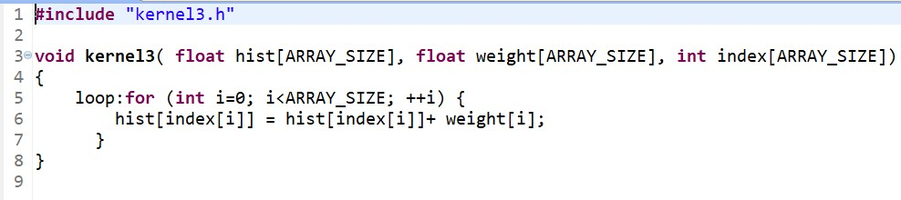

## Optimization Steps

The naïve implementation does not give very good results (see table). The following observations and changes led to an optimized design:

1. The loop can be pipelined using the pipeline directive. But this is not sufficient.
2. The iterations are not independent. There may be a RAW data dependency on the *hist* array in the case where at least 2 *index[i]* in the subsequent 7 iterations have the same value.
3. A perfect initiation interval could not be achieved because of the above unpredictability*.* It cannot be ignored, but we can use a complex logic to check the subsequent 7 *index[i]* values and accumulate the *weight* if necessary. But it will be very expensive in terms of area.
4. Hence, it was only possible to achieve an initiation interval of 7.

## Synthesis Comparison

The synthesis reports for both the implementations can be compared in terms of timing and area:

**Performance Estimates:** The optimized version has the same trip count and iteration latency since the code was unchanged. However, the loop latency is a little better because of pipelining, which led to an improvement in the total latency from 8193 to 7170 cycles.

|  |  |  |  |  |  |  |  |
| --- | --- | --- | --- | --- | --- | --- | --- |
| **Implementation** | **Total Latency** | | **Loop Latency** | | **Iteration Latency** | **Trip Count** | **Initiation Interval** |
| **Min** | **Max** | **Min** | **Max** |
| **Naïve** | 8193 | 8193 | 8192 | 8192 | 8 | 1024 | - |
| **Optimized** | 7170 | 7170 | 7168 | 7168 | 8 | 1024 | 7 |

**Utilization Estimates:** The optimized version uses the same number of DSP48Es but 3 (1%) more FFs and 24 (7.6%) more LUTs compared to the naïve version.

|  |  |  |  |  |  |  |  |  |  |  |
| --- | --- | --- | --- | --- | --- | --- | --- | --- | --- | --- |
| **Implementation** | **BRAM_18K** | | **DSP48E** | | **FF** | | **LUT** | | **URAM** | |
| **Unit** | **%** | **Unit** | **%** | **Unit** | **%** | **Unit** | **%** | **Unit** | **%** |
| **Naïve** | 0 | 0 | 2 | ~0 | 364 | ~0 | 316 | ~0 | 0 | 0 |
| **Optimized** | 0 | 0 | 2 | ~0 | 367 | ~0 | 340 | ~0 | 0 | 0 |

# Kernel-4

The code for the loop kernel is shown below. The code was rewritten for the optimized version.

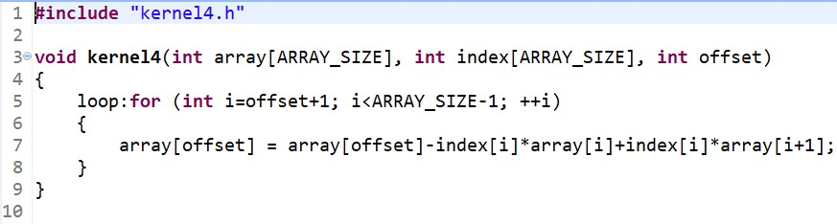

The optimized version of the code is shown below.

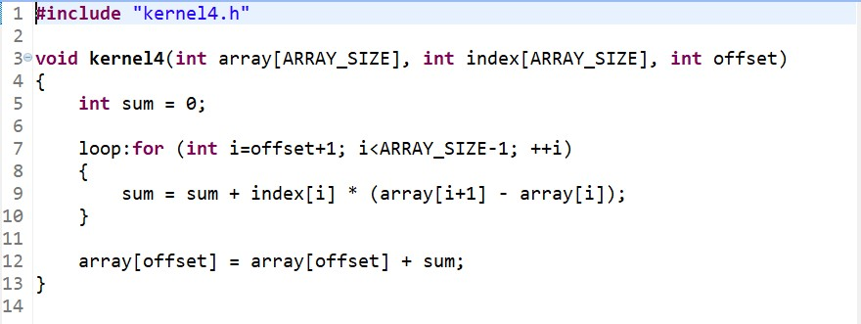

## Optimization Steps

The naïve implementation does not give very good results (see table). The following observations and changes led to an optimized design:

1. The loop can be pipelined using the pipeline directive. But this is not sufficient.
2. The code was rewritten to avoid the RAW dependency which may arise from writing into *array[offset]* and reading *array[i]* or *array[i+1]* at the same time.
3. Further, the final result just needs to be written in one location, hence, it can be pulled out of the loop to reduce memory operations in the loop. The value is accumulated in *sum* and finally added to *array[offset]* in the end.
4. Hence, it was possible to achieve an initiation interval of 1.

## Synthesis Comparison

The synthesis reports for both the implementations can be compared in terms of timing and area:

**Performance Estimates:** The code has variable loop boundaries; hence, we assume a trip count of N (range: 1 to 1022) to calculate the loop latency (5N: naïve, N+2: optimized) and total latency (5N+1: naïve, N+5: optimized) based on the synthesis schedule. The optimized version has the same trip count but a better iteration latency after rewriting the code. The loop latency is 5 times better because of pipelining, which led to an improvement in the total max latency from 5111 to 1027 cycles.

|  |  |  |  |  |  |  |  |
| --- | --- | --- | --- | --- | --- | --- | --- |
| **Implementation** | **Total Latency** | | **Loop Latency** | | **Iteration Latency** | **Trip Count** | **Initiation Interval** |
| **Min** | **Max** | **Min** | **Max** |
| **Naïve** | 6 | 5111 | 5 | 5110 | 5 | N | - |
| **Optimized** | 6 | 1027 | 3 | 1024 | 3 | N | 1 |

**Utilization Estimates:** The optimized version uses 3 (50%) less DSP48Es and 93 (34%) less FFs, but 69 (25%) more LUTs compared to the naïve version.

|  |  |  |  |  |  |  |  |  |  |  |
| --- | --- | --- | --- | --- | --- | --- | --- | --- | --- | --- |
| **Implementation** | **BRAM_18K** | | **DSP48E** | | **FF** | | **LUT** | | **URAM** | |
| **Unit** | **%** | **Unit** | **%** | **Unit** | **%** | **Unit** | **%** | **Unit** | **%** |
| **Naïve** | 0 | 0 | 6 | 1 | 272 | ~0 | 279 | ~0 | 0 | 0 |
| **Optimized** | 0 | 0 | 3 | ~0 | 179 | ~0 | 348 | ~0 | 0 | 0 |

# Kernel-5

The code for the loop kernel is shown below. The same code was used for the optimized version too.

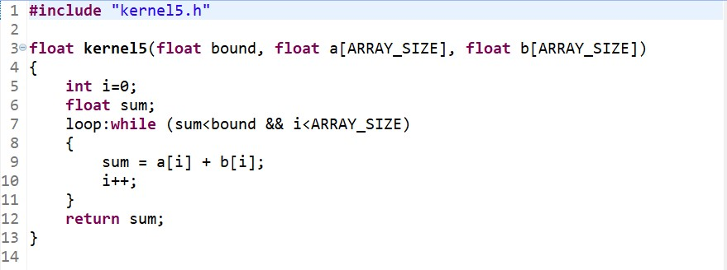

## Optimization Steps

The naïve implementation does not give very good results (see table). The following observations and changes led to an optimized design:

1. The loop can be pipelined using the pipeline directive. But this is not sufficient.
2. There is a control dependency on *sum* which decides the end of loop, because of which there is a stall at every iteration while the exit condition is checked. This prevents from achieving a perfect initiation interval.
3. It could be possible to improve the performance at a high cost of area by using a queue to store the *sum*. It will require complex logic, an inefficient loop to fill the queue and an unrolled loop to shift the queue items. But it will still have the control dependency due to the top item.
4. Hence, it was only possible to achieve an initiation interval of 7.

## Synthesis Comparison

The synthesis reports for both the implementations can be compared in terms of timing and area:

**Performance Estimates:** The code has variable loop boundaries; hence, we assume a trip count of N (range: 1 to 1024) to calculate the loop latency (7N: naïve, 7N: optimized) and total latency (7N+1: naïve, 7N+1: optimized) based on the synthesis schedule. The optimized version simply uses the pipeline directive which could not improve the performance because of the control dependency.

|  |  |  |  |  |  |  |  |
| --- | --- | --- | --- | --- | --- | --- | --- |
| **Implementation** | **Total Latency** | | **Loop Latency** | | **Iteration Latency** | **Trip Count** | **Initiation Interval** |
| **Min** | **Max** | **Min** | **Max** |
| **Naïve** | 8 | 7168 | 7 | 7168 | 7 | N | - |
| **Optimized** | 8 | 7168 | 7 | 7168 | 7 | N | 7 |

**Utilization Estimates:** The optimized version uses the same number of DSP48Es, 3 (0.6%) more FFs and 3 (0.6%) more LUTs compared to the naïve version.

|  |  |  |  |  |  |  |  |  |  |  |
| --- | --- | --- | --- | --- | --- | --- | --- | --- | --- | --- |
| **Implementation** | **BRAM_18K** | | **DSP48E** | | **FF** | | **LUT** | | **URAM** | |
| **Unit** | **%** | **Unit** | **%** | **Unit** | **%** | **Unit** | **%** | **Unit** | **%** |
| **Naïve** | 0 | 0 | 2 | ~0 | 462 | ~0 | 478 | ~0 | 0 | 0 |
| **Optimized** | 0 | 0 | 2 | ~0 | 465 | ~0 | 481 | ~0 | 0 | 0 |

# Kernel-6

The code for the loop kernel is shown below. The code was rewritten for the optimized version.

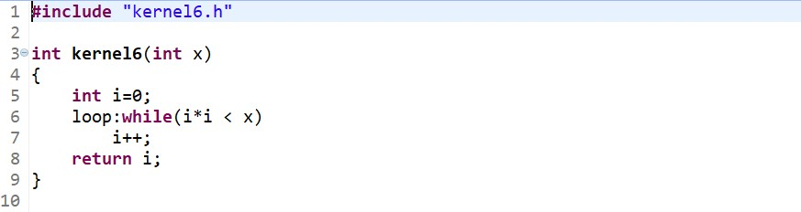

The optimized version of the code is shown below.

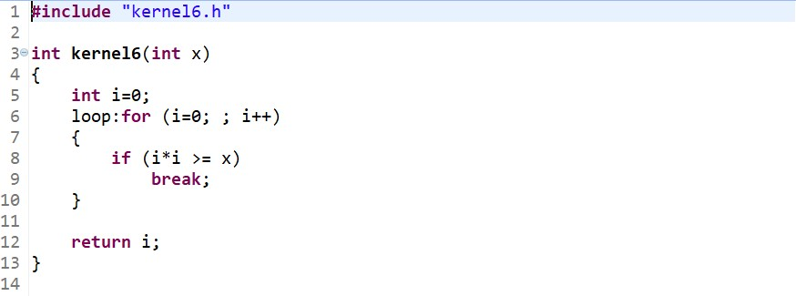

## Optimization Steps

The naïve implementation performs just fine (see table). The following observations and changes led to an optimized design:

1. The naïve implementation is decent because the loop has an iteration latency of just 1.
2. The loop can be pipelined using the pipeline directive, but this is not really necessary.
3. The code was rewritten in an attempt to apply directives and remove the control dependency. But even without it, the performance is optimal because of cheap operations within the loop.
4. Hence, it was possible to achieve an initiation interval of 1.

## Synthesis Comparison

The synthesis reports for both the implementations can be compared in terms of timing and area:

**Performance Estimates:** The code has variable loop boundaries; hence, we assume a trip count of N (range: 0 to inf) to calculate the loop latency (N: naïve, N: optimized) and total latency (N+1: naïve, N+1: optimized) based on the synthesis schedule. Both the versions are similar in design and they give the same performance.

|  |  |  |  |  |  |  |  |
| --- | --- | --- | --- | --- | --- | --- | --- |
| **Implementation** | **Total Latency** | | **Loop Latency** | | **Iteration Latency** | **Trip Count** | **Initiation Interval** |
| **Min** | **Max** | **Min** | **Max** |
| **Naïve** | 1 | (N+1) | 0 | (N) | 1 | N | - |
| **Optimized** | 1 | (N+1) | 0 | (N) | 1 | N | 1 |

**Utilization Estimates:** The optimized version uses the same number of DSP48Es, 1 (3%) more FF and 6 (7%) more LUTs compared to the naïve version.

|  |  |  |  |  |  |  |  |  |  |  |
| --- | --- | --- | --- | --- | --- | --- | --- | --- | --- | --- |
| **Implementation** | **BRAM_18K** | | **DSP48E** | | **FF** | | **LUT** | | **URAM** | |
| **Unit** | **%** | **Unit** | **%** | **Unit** | **%** | **Unit** | **%** | **Unit** | **%** |
| **Naïve** | 0 | 0 | 3 | ~0 | 34 | ~0 | 102 | ~0 | 0 | 0 |
| **Optimized** | 0 | 0 | 3 | ~0 | 35 | ~0 | 108 | ~0 | 0 | 0 |

# Kernel-7

The code for the loop kernel is shown below. The same code was used for the optimized version too.

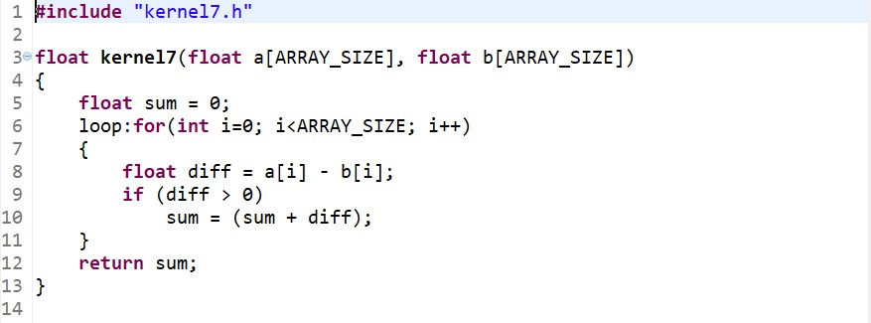

## Optimization Steps

The naïve implementation does not give very good results (see table). The following observations and changes led to an optimized design:

1. The loop can be pipelined using the pipeline directive. But this is not sufficient.
2. There is a control dependency on *diff* followed by a data dependency on *sum* which stalls the pipeline. This prevents from achieving a perfect initiation interval.
3. The problem cannot be solved by simple predication as it will involve a float multiplication with the predicate which is a costly operation, and hence, worsen the performance.
4. It could be possible to improve the performance at a high cost of area by using a queue to store the *diff*. It will require complex logic, an inefficient loop to fill the queue and an unrolled loop to shift the queue items. But it will still have the control dependency due to the top item.
5. Hence, it was only possible to achieve an initiation interval of 4.

## Synthesis Comparison

The synthesis reports for both the implementations can be compared in terms of timing and area:

**Performance Estimates:** The optimized version has the same trip count and iteration latency since the code was unchanged. However, the loop latency is 2.5 times better because of pipelining, which led to an improvement in the total latency from 10241 to 4104 cycles.

|  |  |  |  |  |  |  |  |
| --- | --- | --- | --- | --- | --- | --- | --- |
| **Implementation** | **Total Latency** | | **Loop Latency** | | **Iteration Latency** | **Trip Count** | **Initiation Interval** |
| **Min** | **Max** | **Min** | **Max** |
| **Naïve** | 10241 | 10241 | 10240 | 10240 | 10 | 1024 | - |
| **Optimized** | 4104 | 4104 | 4102 | 4102 | 11 | 1024 | 4 |

**Utilization Estimates:** The optimized version uses the same number of DSP48Es, 63 (14%) more FFs and 41 (8%) more LUTs compared to the naïve version.

|  |  |  |  |  |  |  |  |  |  |  |
| --- | --- | --- | --- | --- | --- | --- | --- | --- | --- | --- |
| **Implementation** | **BRAM_18K** | | **DSP48E** | | **FF** | | **LUT** | | **URAM** | |
| **Unit** | **%** | **Unit** | **%** | **Unit** | **%** | **Unit** | **%** | **Unit** | **%** |
| **Naïve** | 0 | 0 | 2 | ~0 | 457 | ~0 | 500 | ~0 | 0 | 0 |
| **Optimized** | 0 | 0 | 2 | ~0 | 520 | ~0 | 541 | ~0 | 0 | 0 |

# Kernel-8

The code for the loop kernel is shown below. The same code was used for the optimized version too.

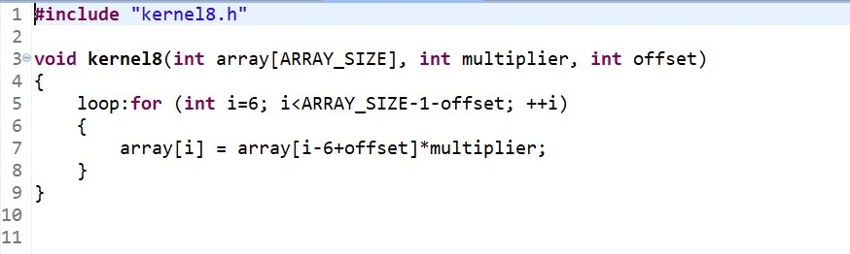

## Optimization Steps

The naïve implementation does not give very good results (see table). The following observations and changes led to an optimized design:

1. The loop can be pipelined using the pipeline directive. But this is not sufficient.
2. The iterations are not independent. There may be a RAW data dependency on the *array* when the indices are within the iteration latency range. This cannot be known beforehand.
3. A perfect initiation interval could not be achieved because of the above unpredictability*.* It cannot be ignored, but we can use a complex logic for prediction and speculation.
4. Hence, it was only possible to achieve an initiation interval of 4.

## Synthesis Comparison

The synthesis reports for both the implementations can be compared in terms of timing and area:

**Performance Estimates:** The code has variable loop boundaries; hence, we assume a trip count of N (range: 1 to 1017) to calculate the loop latency (4N: naïve, 4N: optimized) and total latency (4N+1: naïve, 4N+1: optimized) based on the synthesis schedule. The optimized version simply uses the pipeline directive which could not improve the performance because of the dependencies.

|  |  |  |  |  |  |  |  |
| --- | --- | --- | --- | --- | --- | --- | --- |
| **Implementation** | **Total Latency** | | **Loop Latency** | | **Iteration Latency** | **Trip Count** | **Initiation Interval** |
| **Min** | **Max** | **Min** | **Max** |
| **Naïve** | 5 | 4069 | 4 | 4068 | 4 | N | - |
| **Optimized** | 5 | 4069 | 4 | 4068 | 4 | N | 4 |

**Utilization Estimates:** The optimized version uses the same number of DSP48Es, 1 (0.7%) more FF and 5 (2%) more LUTs compared to the naïve version.

|  |  |  |  |  |  |  |  |  |  |  |
| --- | --- | --- | --- | --- | --- | --- | --- | --- | --- | --- |
| **Implementation** | **BRAM_18K** | | **DSP48E** | | **FF** | | **LUT** | | **URAM** | |
| **Unit** | **%** | **Unit** | **%** | **Unit** | **%** | **Unit** | **%** | **Unit** | **%** |
| **Naïve** | 0 | 0 | 3 | ~0 | 132 | ~0 | 250 | ~0 | 0 | 0 |
| **Optimized** | 0 | 0 | 3 | ~0 | 133 | ~0 | 255 | ~0 | 0 | 0 |

# Conclusion